PYTHON PROGRAMMING – CSA0805
K. Shalini (192512270)

TASK 1: Understand the Problem and Identify the Data
- Aim
To develop a Python program to calculate the milk payment for farmers based on the quantity of milk, fat percentage, SNF percentage, and shift, and to calculate the total payment for ten days.
- Problem Statement
The program accepts the farmer ID, litres of milk, fat percentage, SNF percentage, and shift as inputs. It validates the data, calculates the rate per litre, calculates the payment amount, and determines the total payment for ten days.
- Python Program
The Python program is executed using an online Python compiler. The program accepts the farmer's details, checks the input values, and calculates the payment.
farmer_id = input("Enter Farmer ID: ") litres = float(input("Enter litres of milk: ")) fat = float(input("Enter fat percentage: ")) snf = float(input("Enter SNF percentage: ")) shift = input("Enter shift (Morning/Evening): ") if litres < 0:
print("Invalid litres") elif fat < 2 or fat > 7:
print("Invalid fat percentage") elif snf < 0:
print("Invalid SNF percentage") elif shift.lower() not in ["morning", "evening"]:
print("Invalid shift") else:
rate = (fat * 5) + (snf * 2) amount = litres * rate total = amount * 10 print("Farmer ID:", farmer_id) print("Rate per litre:", rate) print("Payment amount:", amount) print("Ten-day total:", total)
4. Input
The following sample input is used to test the program:
- Farmer ID: F101
- Litres of milk: 10

• Fat percentage: 4
- SNF percentage: 8
- Shift: Morning
- Output
For the given input, the program produces the following output:
  - Farmer ID: F101
  - Rate per litre: 36.0
  - Payment amount: 360.0
  - Ten-day total: 3600.0
- Screenshot Evidence
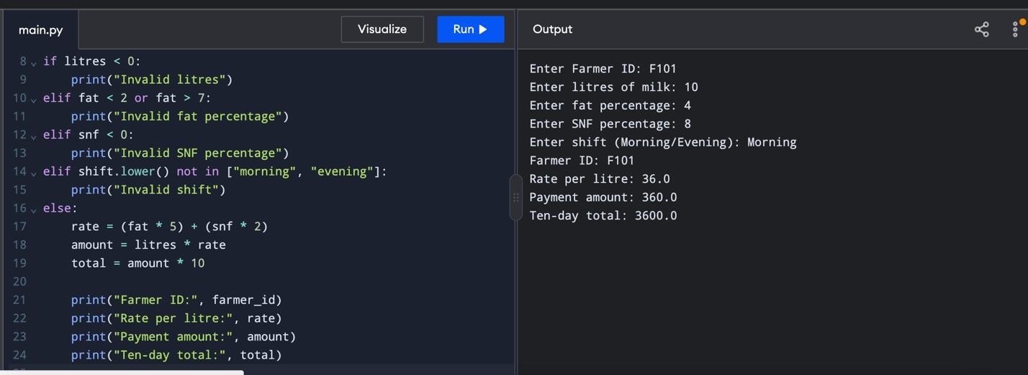
- Analysis of Data
The farmer ID is stored as a string, while litres, fat percentage, SNF percentage, rate, and payment amount are stored as numerical values. The shift is stored as a string. The program validates the litres, fat percentage, SNF percentage, and shift before performing calculations.
- Time and Space Complexity
For (n) farmer entries, processing each entry once requires O(n) time. Storing the details of all farmers using a list or tuple for each entry requires O(n) space. This approach is easier to maintain and suitable for handling 300 farmers.
- Conclusion
The program demonstrates how Python can be used to validate farmer details and calculate milk payments. Using lists or tuples to store farmer records makes the program organized, maintainable, and scalable.

TASK 2 – EXPLORE VALUES AND TYPES IN THE INTERPRETER
- Aim
To explore Python data types, arithmetic operators, floating-point errors, and the use of the Decimal module for accurate money calculations.
- Python Interpreter – Data Types
The type() function is used to identify the data type of a value.
Input and Output:
>>> type(10)
<class 'int'>
>>> type(10.0)
<class 'float'>
>>> type("10")
<class 'str'>
>>> type(True)
<class 'bool'>
>>> type([10, 8.5])
<class 'list'>

Explanation:
int – stores whole numbers. float – stores decimal numbers. str – stores text. bool – stores True or False.
list – stores multiple values in a single variable.
3. Arithmetic Operators
Input and Output:
>>> 7 / 2
3.5
>>> 7 // 2
3
>>> 7 % 2
1
>>> -7 // 2 -4
Explanation: / performs normal division and returns a floating-point result. // performs floor division and rounds down to the nearest integer for these operands. % returns the remainder. -7 // 2 gives -4 because floor division rounds down towards negative infinity. 4. Floating-Point Error
Input and Output:
>>> 0.1 + 0.2 == 0.3
False

>>> 0.1 + 0.2 0.30000000000000004
Explanation:
Computers cannot represent some decimal fractions exactly in binary floating-point format. Therefore, adding 0.1 and 0.2 produces a tiny precision error, and the equality comparison returns False.

5. Complete Python Program
from decimal import Decimal

# 1000 payments of Rs 33.40 and three adjustments of Rs 0.10 payments = ["33.40"] * 1000 + ["0.10"] * 3
def total_float(items):
total = 0.0 for amount in items:
total += float(amount) return total
def total_decimal(items): total = Decimal("0.00") for amount in items:
total += Decimal(amount) return total

print("Float:", total_float(payments)) print("Decimal:", total_decimal(payments))
print(0.1 + 0.2 == 0.3,
Decimal("0.1") + Decimal("0.2") == Decimal("0.3"))
- Input
The program uses the following values:
1,000 payments of ₹33.40
3 adjustments of ₹0.10 each
- Output
Float: 33400.300000000061
Decimal: 33400.30
False True
- Explanation of the Output
The float result contains a small precision error because floating-point numbers cannot represent every decimal fraction exactly.
The Decimal result is 33400.30, which represents the exact total for these decimal-string inputs.
The final line prints False True because floating-point addition is not exactly equal to 0.3, whereas Decimal addition using strings gives an exact decimal result.
- Changing Decimal(amount) to Decimal(float(amount))
If Decimal(amount) is changed to Decimal(float(amount)), the decimal value is created from an already approximated floating-point number. This may introduce precision errors instead of preserving the original decimal amount.
Therefore, Decimal(amount) is preferable when amount is a string representing money.
- Alternative Concept and Complexity Analysis
There are three ways to store and calculate money:
- Decimal
Decimal stores decimal values accurately when created from strings. It is suitable for financial calculations.
- Integer paise
Money can be stored as integer paise. For example, ₹33.40 is stored as 3340 paise. Integer addition is exact and avoids floating-point errors.
- Float with round()
Using round() after every addition can reduce visible errors, but it does not guarantee exact financial calculations in every situation.
For n payments, all three methods require O(n) time to calculate the total. Each payment requires O(1) space, and storing all n payments requires O(n) space.
11. Conclusion
This task demonstrates Python data types, arithmetic operators, and floating-point precision errors. The Decimal module and integer paise are suitable alternatives for accurate money calculations, while ordinary floating-point arithmetic can produce small errors.

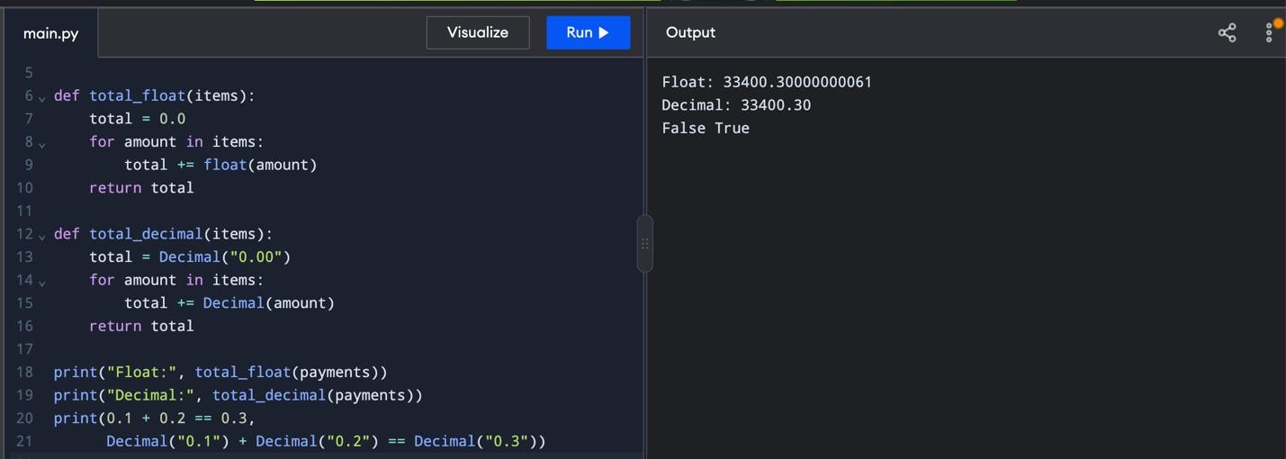

TASK 3 – CHOOSE VARIABLES AND NAME THE CONSTANTS
- Aim
To define meaningful variable names and named constants for milk payment calculations so that rate revisions can be made easily.
- Naming Rules and Conventions
Variable names should be meaningful and easy to understand.
Variable names should start with a letter or underscore.
Spaces are not allowed in variable names.
Constants are written in uppercase letters.
Python keywords should not be used as variable names.
Examples: litres, fat_percent, snf_percent, BASE_RATE.
- Python Program
# Named constants
BASE_RATE = 30.0
FAT_RATE = 0.40
SNF_RATE = 0.30

# Input values
farmer_id = input("Enter Farmer ID: ") litres = float(input("Enter litres: ")) fat = float(input("Enter fat percentage: ")) snf = float(input("Enter SNF percentage: ")) # Calculate rate and payment
rate = BASE_RATE + (fat * FAT_RATE) + (snf * SNF_RATE) amount = litres * rate

# Display results print("Farmer ID:", farmer_id) print("Rate per litre:", rate) print("Payment amount:", amount)
- Sample Input
Enter Farmer ID: F101
Enter litres: 10
Enter fat percentage: 4
Enter SNF percentage: 8
- Expected Output
Farmer ID: F101

Rate per litre: 33.2
Payment amount: 332.0
6. Explanation
Named constants: BASE_RATE, FAT_RATE, and SNF_RATE store the fixed rate values. If the dairy revises its payment rates, the values can be changed in one place.
Dynamic typing: Python automatically determines the data type of a variable. For example:
value = 10 print(type(value))
value = "Milk" print(type(value)) Output:
<class 'int'>
<class 'str'>
The same variable can hold an integer and later hold a string.
Multiple assignment and swapping:
a = 10 b = 20
a, b = b, a print(a, b)
Output:
20 10
Python allows two variables to exchange their values using multiple assignment.
7. Alternative Concept and Complexity Analysis
If rate values are typed directly into expressions, changing the payment rates requires editing multiple expressions wherever those values occur. These values are called magic numbers.
Using named constants makes the program easier to maintain because each rate can be revised in one place.
A dictionary such as RATE_CARD = {"base": 30.0, "fat": 0.40, "snf": 0.30} is another approach. It groups related rate values together and makes the program easier to extend.
For a fixed number of rate values, accessing constants or dictionary entries takes approximately O(1) time. Calculating the payment for each farmer also takes O(1) time. Processing n farmers takes O(n) time.
8. Conclusion
Meaningful variable names and uppercase named constants improve readability and maintainability. Python supports dynamic typing, multiple assignment, and easy value swapping. Named constants and dictionaries help simplify rate revisions.
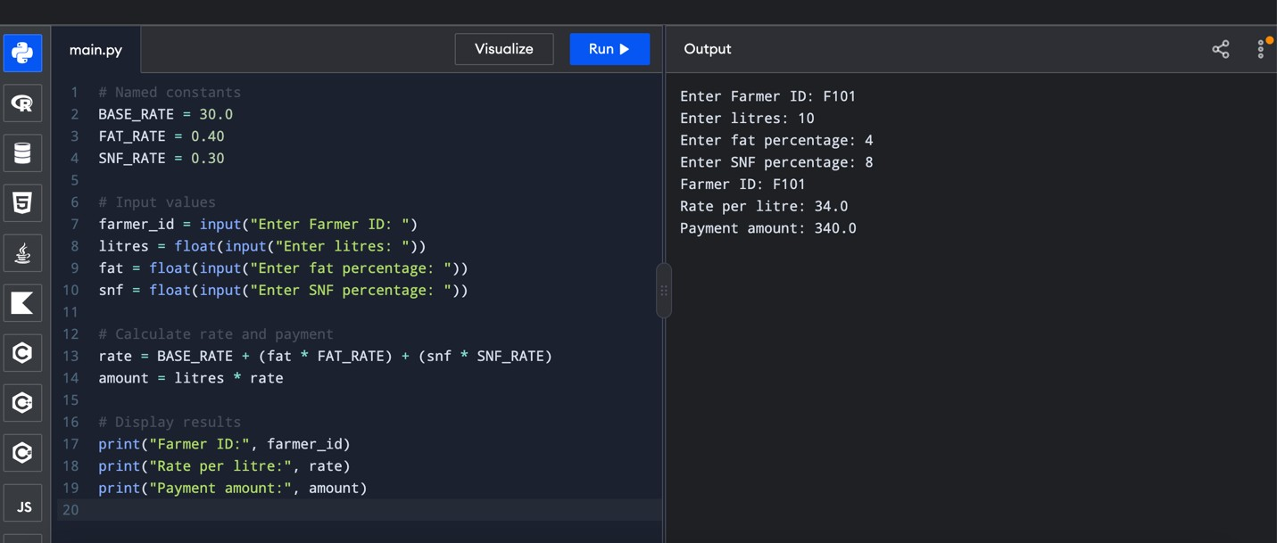

TASK 4 – WRITE CORRECT EXPRESSIONS
- Aim
To write correct Python expressions for calculating fat and SNF steps, rate per litre, and milk payment amount, while understanding operator precedence, rounding, and comparison operators.
- Python Program
import math

BASE_RATE = 30.0
FAT_RATE = 0.40
SNF_RATE = 0.30

farmer_id = "F101" litres = 10.0 fat = 4.2 snf = 8.5

# Calculate fat and SNF steps fat_steps = round((fat - 3.5) / 0.1) snf_steps = round((snf - 8.0) / 0.1)

# Calculate rate and payment
rate = BASE_RATE + fat_steps * FAT_RATE + snf_steps * SNF_RATE amount = litres * rate

print("Farmer ID:", farmer_id) print("Fat steps:", fat_steps) print("SNF steps:", snf_steps) print("Rate per litre:", round(rate, 2)) print("Payment amount:", round(amount, 2))

# Demonstrate rounding and floor print("Fat 4.2:", (4.2 - 3.5) / 0.1) print("Using round:", round((4.2 - 3.5) / 0.1)) print("Using int:", int((3.1 - 3.5) / 0.1)) print("Using floor:", math.floor((3.1 - 3.5) / 0.1))

# Comparison chaining
print("Valid fat:", 2.0 <= fat <= 7.0) print("Valid litres:", litres >= 0)
- Sample Input
Farmer ID: F101
Litres: 10.0
Fat percentage: 4.2 SNF percentage: 8.5
- Expected Output
Farmer ID: F101
Fat steps: 7
SNF steps: 5
Rate per litre: 33.3
Payment amount: 333.0
Fat 4.2: 7.000000000000001
Using round: 7
Using int: -3

Using floor: -4
Valid fat: True
Valid litres: True
5. Explanation of Expressions
A. Fat and SNF steps
The fat steps are calculated using:
round((fat - 3.5) / 0.1)
For fat = 4.2, the mathematical result is 7 steps. However, binary floating-point representation may produce 7.000000000000001. The round() function gives the intended whole-number step count.
The SNF steps are calculated similarly, using 8.0 as the assumed reference value. B. Rate per litre rate = BASE_RATE + fat_steps * FAT_RATE + snf_steps * SNF_RATE
The rate is calculated by adding the base rate and the contributions from fat and SNF steps.
- Payment amount amount = litres * rate
The payment amount is calculated by multiplying the litres of milk by the rate per litre.
- Operator precedence
Python performs exponentiation before unary minus, and multiplication before addition.
Examples:
2 + 3 * 4 gives 14.
-2 ** 2 gives -4.
(-2) ** 2 gives 4.
Parentheses can change the order of evaluation.
- Difference between round(), int(), and math.floor()
For the value (3.1 - 3.5) / 0.1:
round() gives approximately -4.
int() gives -3 because it truncates towards zero. math.floor() gives -4 because it rounds down towards negative infinity.
For fat = 4.2, the calculated step count is 7 when round() is used.
- Comparison chaining
2.0 <= fat <= 7.0 checks whether the fat percentage is between 2.0 and 7.0, inclusive.
litres >= 0 checks that the milk quantity is not negative.
These expressions return either True or False.
- Alternative Concept and Complexity Analysis
If int() or math.floor() is used instead of round() to calculate the number of steps, the result may change, especially for negative values. This can produce an incorrect rate.
Using round() gives the intended step count for the examples in this task. For more robust calculations, integer units or Decimal arithmetic can be considered.
Each arithmetic expression takes O(1) time and O(1) additional space because it performs a fixed number of operations.
- Conclusion
Correct expressions are important for accurate milk payment calculations. Understanding operator precedence, floating-point precision, rounding, and comparison chaining helps avoid calculation errors and ensures proper validation.
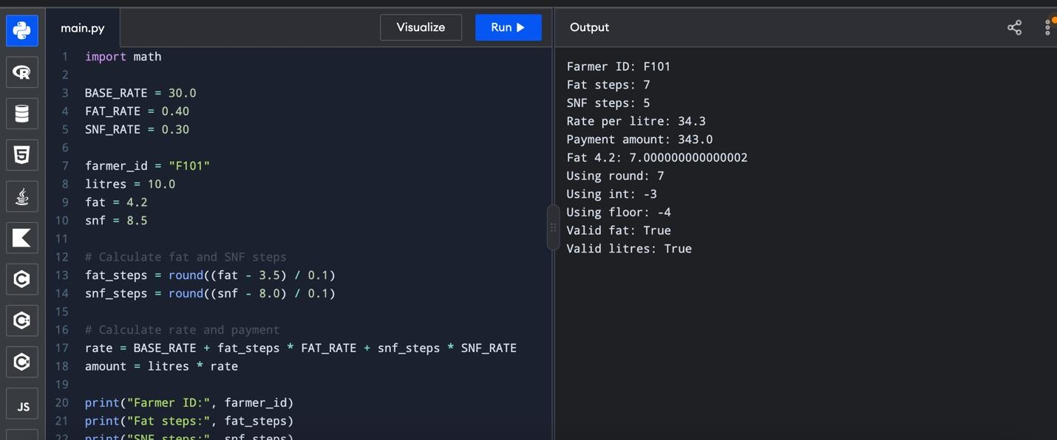

TASK 5 – READ INPUT AND CONVERT TYPES
- Aim
To read the clerk's entries, convert input values into the correct data types, validate the input, and display the payment details in an aligned format.
- Python Program
BASE_RATE = 30.0
FAT_RATE = 0.40
SNF_RATE = 0.30

farmer_id = input("Enter Farmer ID: ")
try:
litres = float(input("Enter litres: ")) fat = float(input("Enter fat percentage: ")) snf = float(input("Enter SNF percentage: "))
if litres < 0 or not 2.0 <= fat <= 7.0 or snf < 0:
print("Invalid input values") else:
rate = BASE_RATE + fat * FAT_RATE + snf * SNF_RATE amount = litres * rate

print("\n----- MILK PAYMENT DETAILS -----") print(f"{'Farmer ID':<15}: {farmer_id}") print(f"{'Litres':<15}: {litres:8.2f}") print(f"{'Fat %':<15}: {fat:8.2f}") print(f"{'SNF %':<15}: {snf:8.2f}") print(f"{'Rate/Litre':<15}: {rate:8.2f}") print(f"{'Amount':<15}: {amount:8.2f}")
except ValueError: print("Error: Please enter valid numeric values")
- Sample Input
Enter Farmer ID: F101
Enter litres: 10
Enter fat percentage: 4.2
Enter SNF percentage: 8.5
- Expected Output
----- MILK PAYMENT DETAILS -----
Farmer ID : F101
Litres : 10.00
Fat % : 4.20
SNF % : 8.50
Rate/Litre : 34.23
Amount : 342.30
- Explanation
Why does input() return a string?
Python's input() function always returns the entered value as a string. Therefore, float() is used to convert litres, fat percentage, and SNF percentage into decimal numbers.
What happens if the clerk enters "8.5" or "eight"?
Entering 8.5 is successfully converted into a floating-point number.
Entering eight causes a ValueError, which is handled by the except block. The program displays an error message instead of stopping unexpectedly.
How is the input validated?
The program checks that litres are not negative, fat percentage is between 2.0 and 7.0, and SNF percentage is not negative.
How are aligned results printed?
The expression f"{amount:8.2f}" reserves eight character spaces and displays two digits after the decimal point. The expression f"{'Farmer ID':<15}" left-aligns the label within 15 characters.
- Alternative Concept and Complexity Analysis
Using float() directly without exception handling can cause the program to stop if invalid text is entered. Using try-except makes input handling safer.
For one farmer, reading and calculating the payment takes O(1) time and O(1) additional space. For n farmers, processing each farmer once takes O(n) time.
- Conclusion
The program demonstrates input conversion, numeric validation, exception handling, and formatted output using Python. These techniques help prevent input errors and display milk payment details clearly.
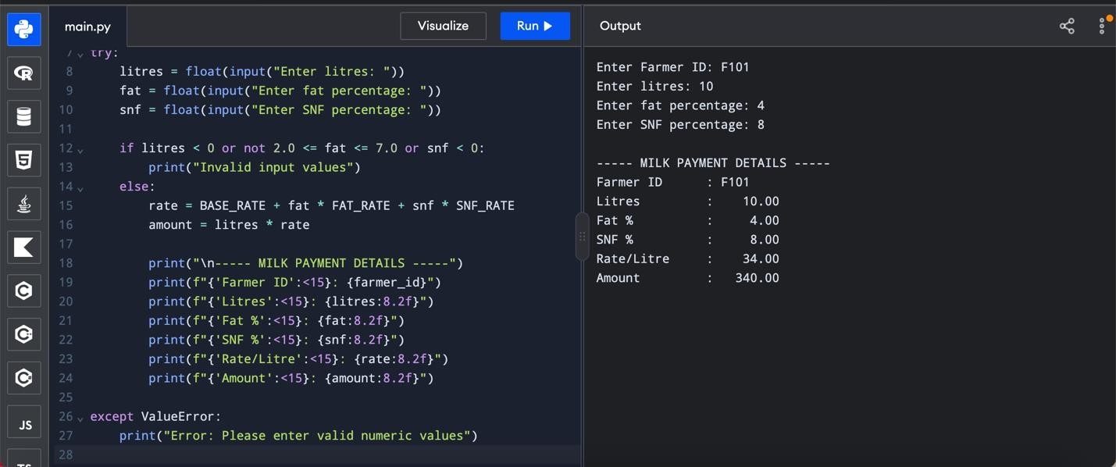

TASK 6 – ORGANISE THE LOGIC INTO FUNCTIONS
- Aim
To divide the milk-payment calculation into reusable Python functions using parameters, return values, local variables, global constants, and docstrings.
- Python Program

# Global constants
BASE_RATE = 30.00
FAT_STEP_VALUE = 0.40
SNF_STEP_VALUE = 0.30
BASE_FAT = 3.5
BASE_SNF = 8.5
def rate_per_litre(fat, snf):
"""Calculate the milk rate per litre.""" fat_steps = round((fat - BASE_FAT) / 0.1) snf_steps = round((snf - BASE_SNF) / 0.1)

rate = (BASE_RATE
+ fat_steps * FAT_STEP_VALUE + snf_steps * SNF_STEP_VALUE) return round(rate, 2)
def payout(litres, rate):
"""Calculate payment for the supplied milk.""" return round(litres * rate, 2)
def ten_day_total(daily_amount):
"""Calculate the total payment for ten days.""" return round(daily_amount * 10, 2)

# Input
farmer_id = input("Enter Farmer ID: ") litres = float(input("Enter litres of milk: ")) fat = float(input("Enter fat percentage: ")) snf = float(input("Enter SNF percentage: "))

# Function calls rate = rate_per_litre(fat, snf) amount = payout(litres, rate) total = ten_day_total(amount)
# Output
print("\n--- MILK PAYMENT DETAILS ---") print("Farmer ID:", farmer_id) print("Rate per litre:", rate) print("Daily payment:", amount) print("Ten-day total:", total)
- Sample Input
Enter Farmer ID: F101
Enter litres of milk: 10
Enter fat percentage: 4.2
Enter SNF percentage: 8.5
- Expected Output
--- MILK PAYMENT DETAILS ---
Farmer ID: F101
Rate per litre: 32.8
Daily payment: 328.0 Ten-day total: 3280.0
- Explanation
Functions Used
rate_per_litre(fat, snf) calculates the rate using fat and SNF percentages.
payout(litres, rate) calculates the daily payment. ten_day_total(daily_amount) calculates the total payment for ten days.
Parameters and Return Values
Parameters are the input values passed to a function. For example, fat and snf are parameters of rate_per_litre().
The return statement sends the calculated result back to the calling code. This allows the returned value to be stored in a variable and reused.
Local and Global Variables
Global constants such as BASE_RATE, FAT_STEP_VALUE, and SNF_STEP_VALUE are defined outside the functions and can be read inside them.
Variables such as fat_steps, snf_steps, and rate inside rate_per_litre() are local variables. They are used only within that function.
Purpose of Docstrings
A docstring is a description written inside triple quotation marks at the beginning of a function. It explains the purpose of the function and makes the code easier to understand.
- Alternative Concept and Complexity Analysis
If the entire calculation were written as one long script, the code would be harder to read, test, and maintain. Using functions avoids repeating the same calculation and makes each part reusable.
Lambda expressions can be used for short, simple calculations, but named functions are more suitable here because they support clear names, multiple statements, and docstrings.
Each function performs a fixed number of operations, so its time complexity is O(1). Processing n farmers takes O(n) time if each farmer is processed once. The functions use O(1) additional space per calculation.
- Conclusion
The program demonstrates modular programming using functions, parameters, return values, global constants, local variables, and docstrings. Dividing the milk-payment calculation into functions improves readability, reusability, testing, and maintenance.
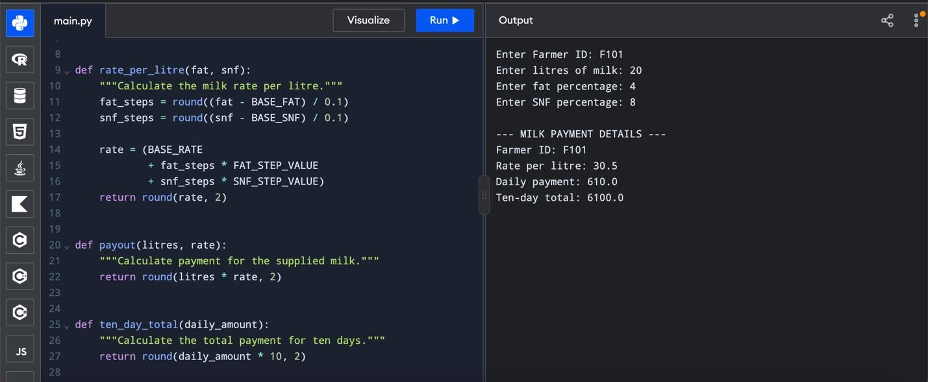

TASK 7 – BUILD A MODULE
- Aim
To create a Python module named milkcrate.py containing the milk rate card and calculation functions, and import it into a separate Python script.
- Python Program – File 1: milkcrate.py
"""Rate card and payment functions for village milk co-operative."""

BASE_RATE = 30.00
FAT_STEP_VALUE = 0.40
SNF_STEP_VALUE = 0.30
BASE_FAT = 3.5
BASE_SNF = 8.5
def rate_per_litre(fat, snf): """Calculate milk rate per litre.""" fat_steps = round((fat - BASE_FAT) / 0.1) snf_steps = round((snf - BASE_SNF) / 0.1)

rate = (BASE_RATE
+ fat_steps * FAT_STEP_VALUE + snf_steps * SNF_STEP_VALUE) return round(rate, 2)
def payout(litres, rate):
"""Calculate payment for milk supplied.""" return round(litres * rate, 2)
def ten_day_total(daily_amount):
"""Calculate total payment for ten days.""" return round(daily_amount * 10, 2)
if __name__ == "__main__":
litres = float(input("Enter litres: ")) fat = float(input("Enter fat percentage: ")) snf = float(input("Enter SNF percentage: "))

rate = rate_per_litre(fat, snf) amount = payout(litres, rate) total = ten_day_total(amount)

print("Rate per litre:", rate) print("Daily payment:", amount) print("Ten-day total:", total)
3. Python Program – File 2: main.py
from milkcrate import rate_per_litre, payout, ten_day_total

farmer_id = input("Enter Farmer ID: ") litres = float(input("Enter litres: ")) fat = float(input("Enter fat percentage: ")) snf = float(input("Enter SNF percentage: "))

rate = rate_per_litre(fat, snf) amount = payout(litres, rate) total = ten_day_total(amount)

print("\n--- MILK PAYMENT DETAILS ---") print("Farmer ID:", farmer_id) print("Rate per litre:", rate) print("Daily payment:", amount) print("Ten-day total:", total)
- Sample Input
Enter Farmer ID: F101
Enter litres: 10
Enter fat percentage: 4.2
Enter SNF percentage: 8.5
- Expected Output
--- MILK PAYMENT DETAILS ---
Farmer ID: F101
Rate per litre: 32.8
Daily payment: 328.0 Ten-day total: 3280.0
- Explanation
- Importing a module
The statement from milkcrate import payout imports the payout() function from the milkcrate module.
The statement import milkcrate as mr imports the entire module and allows its functions to be called using mr.payout().
- Purpose of if __name__ == "__main__"
When milkcrate.py is executed directly, its __name__ variable is set to "__main__", so the input and calculation code runs.
When milkcrate.py is imported into another script, its __name__ is "milkcrate". The code inside the if block does not run, but its functions and constants can be imported and used.
Without this condition, the input and calculation statements at the module's top level would execute during import.
- Using the standard library
Python provides built-in modules such as math, random, and decimal. They can be imported to use existing functions instead of writing everything from scratch.
For example:
import math print(math.floor(4.8))
Output:
4
- Where Python searches for modules
Python searches for imported modules using its module search path, available through sys.path. The script's directory is normally included, along with other configured locations such as standard-library and installed-package directories.
Therefore, milkcrate.py and main.py should be saved in the same folder for this example to work.
- Alternative Concept and Complexity Analysis
If all calculations are written in one script, the code becomes harder to reuse and maintain. A module allows the same functions to be imported into multiple programs.
For each farmer, the calculation functions take O(1) time and O(1) additional space. Processing n farmers takes O(n) time when each farmer is processed once.
- Conclusion
The program demonstrates how to create and import a Python module. Using separate modules improves code reuse, readability, testing, and maintenance. The if __name__ == "__main__" condition prevents the standalone execution code from running when the module is imported.
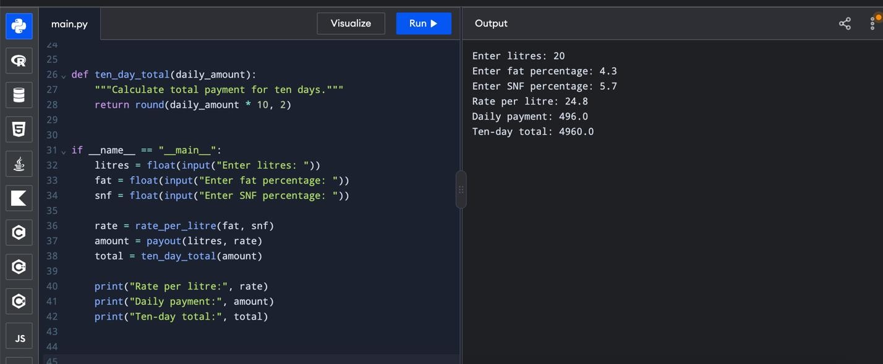

TASK 8 – PLAN THE ALGORITHM BEFORE CODING
- Aim
To plan the algorithm for calculating milk payment for farmers over ten days using pseudocode, a flowchart, and a hand trace.
- Problem Statement
The program calculates the rate per litre based on fat and SNF percentages, calculates the payment for the milk supplied, and adds the payments to obtain the ten-day total.
The base rate is ₹30.00 per litre at 3.5% fat and 8.5% SNF. Every 0.1% change in fat changes the rate by ₹0.40, and every 0.1% change in SNF changes the rate by ₹0.30.
- Algorithm
  - Start the program.
  - Set the base rate to ₹30.00, fat step value to ₹0.40, and SNF step value to ₹0.30.
  - Set the total payment to zero.
  - Read the farmer ID, litres, fat percentage, and SNF percentage.
  - Validate the input values.
  - Calculate fat steps and SNF steps.
  - Calculate the rate per litre.
  - Calculate the payment amount by multiplying litres by the rate.
  - Add the payment amount to the running total.
  - Repeat for all farmer entries.
  - Display the payment details and total payment.
  - Stop the program.
- Pseudocode
BEGIN

BASE_RATE = 30.00
FAT_STEP_VALUE = 0.40
SNF_STEP_VALUE = 0.30
TOTAL = 0

FOR each farmer entry

READ farmer_id, litres, fat, snf

IF litres < 0 OR fat < 2.0 OR fat > 7.0
OR snf < 0 THEN
DISPLAY "Invalid input"
ELSE
FAT_STEPS = ROUND((fat - 3.5) / 0.1)
SNF_STEPS = ROUND((snf - 8.5) / 0.1)

RATE = BASE_RATE
+ FAT_STEPS * FAT_STEP_VALUE
+ SNF_STEPS * SNF_STEP_VALUE

AMOUNT = litres * RATE
TOTAL = TOTAL + AMOUNT

DISPLAY farmer_id, RATE, AMOUNT
END IF

END FOR

DISPLAY TOTAL

END
5. Flowchart
┌──────────────┐
│ START │
└──────┬───────┘
│
┌──────▼───────┐
│ Initialize │
│ rate values │
│ TOTAL = 0 │
└──────┬───────┘ │
┌──────▼───────┐
│ Read farmer │
│ input values │
└──────┬───────┘ │
┌──────▼───────┐
│ Validate │
│ inputs │
└──────┬───────┘
│
┌─────▼─────┐
│ Valid? │
└──┬─────┬──┘
No│ │Yes
┌───────▼─┐ ┌─▼─────────────┐
│ Display │ │ Calculate rate│
│ error │ │ and payment │
└─────┬───┘ └──────┬────────┘ │ │
│ ┌──────▼────────┐
│ │ Add payment │
│ │ to TOTAL │
│ └──────┬────────┘
│ │
└──────┬─────┘
│
┌────────▼────────┐
│ More entries? │
└────┬────────┬───┘
Yes│ │No
┌─────▼───┐ ┌──▼───────────┐
│ Read │ │ Display total│
│ next │ └──────┬───────┘ │ entry │ │
└─────────┘ ┌──────▼───────┐
│ STOP │
└──────────────┘
- Hand Trace for Three Entries
Litres Fat % SNF % Rate per litre Payment
10.0 3.5 8.5 ₹30.00 ₹300.00
8.5 4.2 8.7 ₹33.40 ₹283.90
12.0 3.1 8.3 ₹27.80 ₹333.60
Total payment calculation:
₹300.00 + ₹283.90 + ₹333.60 = ₹917.50
- Alternative Concept and Complexity Analysis
There are two ways to calculate the total payment.
Method 1: Store all entries in a list
All farmer entries are stored in a list, and the total is calculated after processing them. The time complexity is O(n), and the space complexity is O(n), because all entries must be stored.
Method 2: Use a running total
Each payment is added to TOTAL immediately after calculation. The time complexity is O(n), and the additional space complexity is O(1), excluding the current entry and any stored output.
The running-total method is more memory-efficient when only the final total is required. A list is useful when all farmer records must be retained for later analysis.
- Conclusion
Planning the algorithm before coding helps organize the calculation steps and identify validation requirements. Pseudocode, flowcharts, and hand tracing help detect errors before implementation and make the program easier to understand and test.
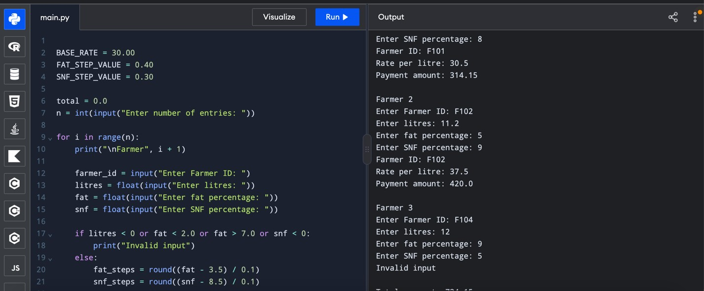

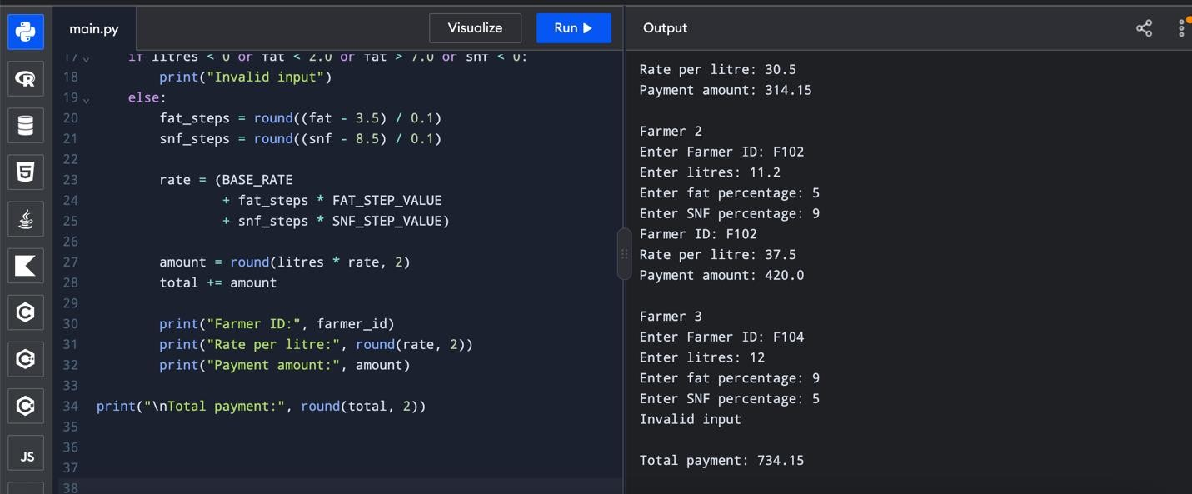

TASK 9 – IMPLEMENT AND TEST THE CALCULATOR
Aim: To implement the milk payment calculator and test its accuracy using normal values, boundary values, and invalid inputs.
Testing Method: The program uses a test function with assertions to compare the actual results with the expected results.
Test Cases:
Test case Input Expected result
Normal entry Fat 4.2, SNF 8.7 Payment calculated
Below standard Fat 3.1, SNF 8.3 Payment calculated
Minimum fat Fat 2.0 Valid
Maximum fat Fat 7.0 Valid
Text input Litres = "ten" Rejected
Negative quantity Litres = -5 Rejected
Fat below range Fat = 1.9 Rejected
Fat above range Fat = 7.1 Rejected
Five-Entry Total Calculation:
₹300.00 + ₹283.90 + ₹333.60 + ₹120.00 + ₹264.00 = ₹1,301.50
Conclusion: The calculator passed all the programmed test cases. The results confirm that normal entries and valid boundary values are accepted, invalid entries are rejected, and the fiveentry total matches the manual calculation.
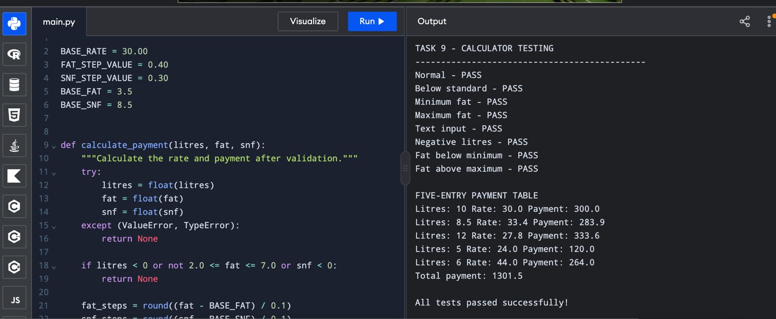

TASK 10 – COMPARE EXPECTATIONS WITH EXECUTION (4 MARKS)
- Aim
To compare the expected and actual results of milk payment calculations using float and Decimal for 300, 6,000, and 150,000 payments, measure execution time, and analyse the effect of rounding each payment versus rounding the final total.
- Problem Statement
Floating-point numbers may produce small precision errors because some decimal values cannot be represented exactly in binary. This task compares floating-point arithmetic with Decimal arithmetic and examines the effect of different rounding methods on financial calculations.
- Algorithm
  - Import the Decimal module and perf_counter function.
  - Create a list containing sample milk payment rates.
  - Repeat the list to generate 300, 6,000, and 150,000 payments.
  - Calculate the total using floating-point arithmetic.
  - Measure the execution time using perf_counter().
  - Calculate the total using Decimal arithmetic.
  - Measure the Decimal execution time.
  - Compare both totals and calculate their difference.
  - Compare rounding each payment with rounding only the final total.
  - Display the results and conclude which method is suitable for financial calculations.
- Python Program
from decimal import Decimal, ROUND_HALF_UP from time import perf_counter

payments = ["33.40", "27.80", "30.00", "33.90", "24.00"]
def compare_totals(n):
values = (payments * ((n + 4) // 5))[:n]

start = perf_counter()
float_total = sum(float(x) for x in values) float_time = perf_counter() - start

start = perf_counter()
decimal_total = sum(Decimal(x) for x in values) decimal_time = perf_counter() - start

difference = abs(Decimal(str(float_total)) - decimal_total)

print("\nNumber of payments:", n)
print("Float total:", format(float_total, ".2f")) print("Decimal total:", decimal_total) print("Difference:", difference)
print("Float time:", round(float_time, 6), "seconds") print("Decimal time:", round(decimal_time, 6), "seconds")

print("TASK 10 - COMPARE EXPECTATIONS WITH EXECUTION")
for n in [300, 6000, 150000]:
compare_totals(n)

print("\nROUNDING COMPARISON")

amounts = [Decimal("10.005"), Decimal("20.005")]

round_each = sum(
amount.quantize(Decimal("0.01"), rounding=ROUND_HALF_UP) for amount in amounts
)

round_final = sum(amounts).quantize(
Decimal("0.01"), rounding=ROUND_HALF_UP
)

print("Rounding each payment:", round_each) print("Rounding final total:", round_final)
5. Sample Output
The following totals are expected. Execution times and tiny precision differences depend on the computer and Python environment.
TASK 10 - COMPARE EXPECTATIONS WITH EXECUTION

Number of payments: 300
Float total: 8946.00
Decimal total: 8946.00

Number of payments: 6000
Float total: 178920.00
Decimal total: 178920.00

Number of payments: 150000
Float total: 4473000.00
Decimal total: 4473000.00

ROUNDING COMPARISON
Rounding each payment: 30.02
Rounding final total: 30.01
The program also prints the actual difference and execution time for each calculation. Include those measured values in your final report.
6. Analysis of Results
- Float and Decimal Comparison
Both methods produce the same totals to two decimal places for the sample payments. However, float can contain small internal precision errors because decimal fractions are represented in binary floating-point format.
Decimal provides exact decimal arithmetic for these inputs because the values are created from strings.
- Execution Time
The perf_counter() function measures the time taken by each calculation. Floating-point arithmetic is generally faster than Decimal arithmetic, although actual execution times depend on the computer and Python environment.
As the number of payments increases, the total processing time also generally increases.
- Rounding Each Payment Versus Rounding the Final Total
The program uses two amounts: ₹10.005 and ₹20.005.
Rounding each payment first gives ₹10.01 + ₹20.01 = ₹30.02.
Adding the original amounts and rounding the final total gives ₹30.01.
The results differ because rounding is performed at different stages. The co-operative must follow its approved accounting policy to determine the correct method.
- Reasons for Differences
Differences can occur because of floating-point representation, the stage at which rounding is applied, and the number of payments processed. Therefore, financial calculations should use a clearly defined decimal precision and rounding policy.
- Alternative Concept and Complexity Analysis
The rate table can be calculated once and stored in a dictionary instead of recalculating rates for every farmer. Dictionary lookup takes O(1) average time, but storing the table requires additional space.
For n payments, calculating the total takes O(n) time. Since this program stores all payment entries in a list, its space complexity is O(n).
- Conclusion
The experiment compares floating-point and Decimal arithmetic for different numbers of payments. Decimal is more suitable for financial calculations because it supports exact decimal values when constructed from strings. A consistent rounding policy is necessary to ensure correct bank payments. Execution-time measurements help compare the performance of both approaches.
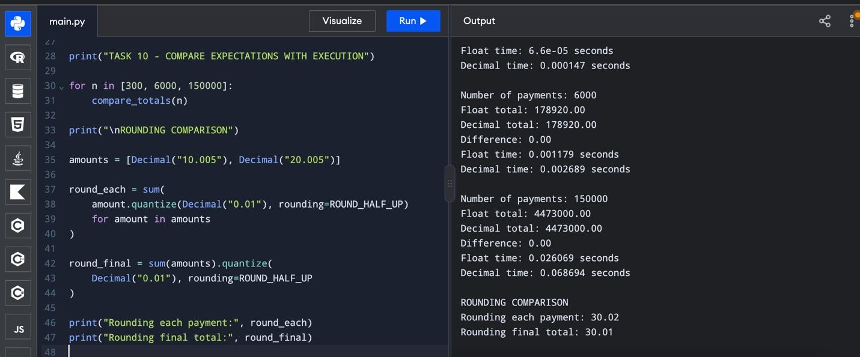

TASK 11 – RECOMMEND AND DEFEND THE FINAL DESIGN (4 MARKS)
- Aim
To recommend and justify the final design of a milk-payment calculator for a village cooperative based on accuracy, testing, maintainability, and performance.
- Recommended Final Design
I recommend a modular Python program that uses named constants, reusable functions, Decimal arithmetic, input validation, and a running total. This design is suitable for calculating milk payments accurately and processing many farmer entries.
- Data Types and Rounding Rule
The farmer ID is stored as a string because it may contain letters and numbers. Litres, fat percentage, SNF percentage, and payment values are stored using Decimal for reliable decimal calculations.
Each farmer's payment is rounded to two decimal places using the half-up rounding rule before it is added to the total. This ensures that the total agrees with the sum of individual payment amounts.
- Functions and Module Design
The program is divided into functions for calculating the rate, calculating the payment, and calculating the total. This improves readability, testing, and reuse.
The rate card is stored separately from the calculation logic. Therefore, the rates can be changed without rewriting the main calculation functions.
- Input Validation
The program checks that litres are not negative, fat percentage is between 2% and 7%, and SNF percentage is not negative. Invalid entries are rejected to prevent incorrect payments.
- Evidence from Testing
The earlier tests covered normal entries, minimum and maximum fat values, negative litres, invalid text input, and five farmer entries. The five-entry example produced a total payment of ₹1,301.50.
The float-versus-Decimal experiment demonstrated why Decimal is preferable for financial calculations. Execution times should be taken from the actual compiler results.
- Limitations
The design depends on the accuracy of the rate card and validation rules. Changes in the cooperative's payment policy require the rate card or calculation rules to be updated. For larger operations, database storage, duplicate-entry checks, user authentication, and audit records would be necessary.
3. Python Program – Final Recommended Design
from decimal import Decimal, ROUND_HALF_UP

# Rate card
BASE_RATE = Decimal("30.00")
FAT_STEP_VALUE = Decimal("0.40")
SNF_STEP_VALUE = Decimal("0.30")
BASE_FAT = Decimal("3.5")
BASE_SNF = Decimal("8.5")
STEP = Decimal("0.1")
CENT = Decimal("0.01")
def round_money(value):
"""Round a money value to two decimal places.""" return value.quantize(CENT, rounding=ROUND_HALF_UP)
def calculate_rate(fat, snf):
"""Calculate the milk rate per litre.""" fat_steps = int(
((fat - BASE_FAT) / STEP).quantize(
Decimal("1"), rounding=ROUND_HALF_UP
)
)
snf_steps = int(
((snf - BASE_SNF) / STEP).quantize(
Decimal("1"), rounding=ROUND_HALF_UP
)
)
rate = ( BASE_RATE
+ Decimal(fat_steps) * FAT_STEP_VALUE
+ Decimal(snf_steps) * SNF_STEP_VALUE
)
return round_money(rate)
def calculate_payment(litres, fat, snf): """Calculate the payment for one farmer.""" if litres < 0:
raise ValueError("Litres cannot be negative")
if not Decimal("2.0") <= fat <= Decimal("7.0"):
raise ValueError("Fat must be between 2.0 and 7.0")
if snf < 0:
raise ValueError("SNF cannot be negative")

rate = calculate_rate(fat, snf) amount = round_money(litres * rate)

return rate, amount
def main(): entries = [
("F101", "10", "3.5", "8.5"),
("F102", "8.5", "4.2", "8.7"),
("F103", "12", "3.1", "8.3"),
("F104", "5", "2.0", "8.5"),
("F105", "6", "7.0", "8.5")
]
total = Decimal("0.00")

print("FINAL MILK PAYMENT REPORT") print("-" * 55)
for farmer_id, litres, fat, snf in entries:
litres = Decimal(litres) fat = Decimal(fat) snf = Decimal(snf)

rate, amount = calculate_payment(litres, fat, snf) total += amount
print( farmer_id, "| Rate:", rate,
"| Payment:", amount
)
print("-" * 55)
print("Total payment: Rs.", total)
if __name__ == "__main__": main()
- Sample Output
FINAL MILK PAYMENT REPORT
-------------------------------------------------------
F101 | Rate: 30.00 | Payment: 300.00
F102 | Rate: 33.40 | Payment: 283.90
F103 | Rate: 27.80 | Payment: 333.60
F104 | Rate: 24.00 | Payment: 120.00
F105 | Rate: 44.00 | Payment: 264.00
------------------------------------------------------- Total payment: Rs. 1301.50
- Alternative Concept and Complexity Analysis
The rate card could be stored in a separate text or JSON file and loaded when the program starts. This makes rate revisions easier because the rate data can be updated without modifying the calculation module.
However, loading an external file adds start-up time and requires error handling if the file is missing or incorrectly formatted. For a small co-operative, a separate rate-card file is practical. For a larger system, a managed database or centrally maintained configuration would be more suitable.
Processing n farmer entries takes O(n) time. The program stores the example entries in a list, so its space complexity is O(n). A streaming version that reads and processes one farmer at a time can use O(1) additional working space, excluding stored records.
- Conclusion
The recommended design uses Decimal arithmetic, reusable functions, a separate rate card, input validation, and a running total. It provides reliable payment calculations and is easier to maintain than a single long script. For larger operations, database integration, access control, audit logs, and central rate management should be added before deployment.
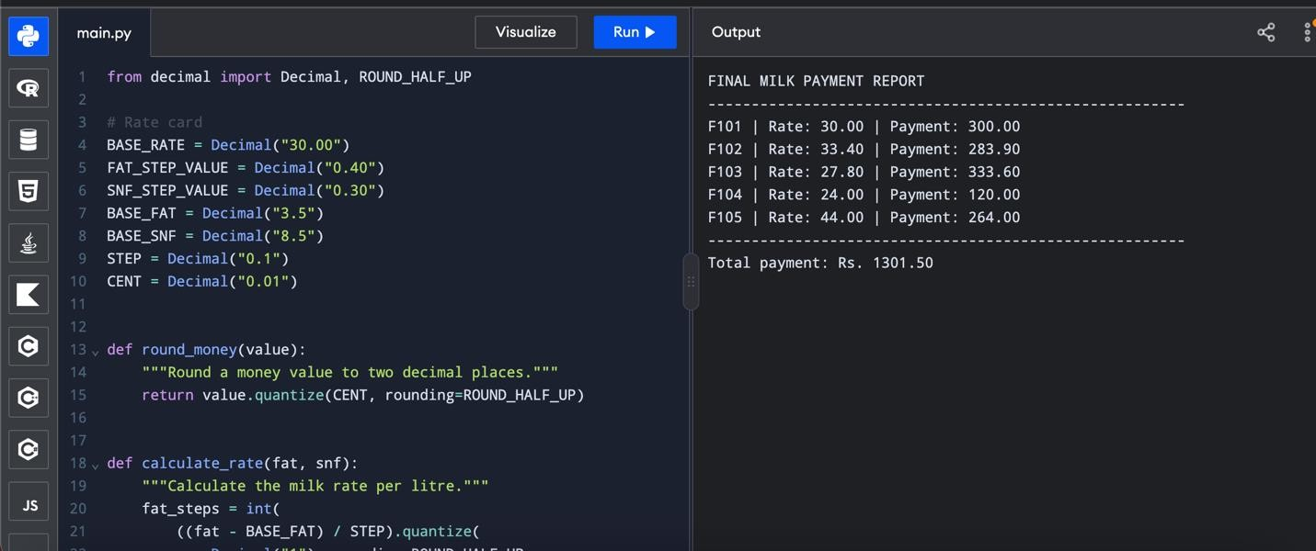

TASK 12 – RE-EVALUATE AND ADAPT THE DESIGN (8 MARKS)
- Impact Analysis – 2 Marks
The original milk-payment calculator must be modified to support the new requirements.
  - Input precision: The automatic milk analyzer now sends fat and SNF readings to two decimal places. The program must preserve these readings and calculate the nearest 0.1% step correctly.
  - Seasonal rate changes: From April to June, the base rate changes to ₹32.00 per litre, and each fat step is worth ₹0.45 instead of ₹0.40.
  - SNF rate: The SNF step value remains ₹0.30 per 0.1% step, based on the original rate card.
  - Bonus calculation: Farmers supplying more than 500 litres in ten days receive a bonus of ₹0.50 per litre. A farmer supplying exactly 500 litres does not qualify.
  - Affected components: The rate constants, rate calculation function, ten-day total calculation, input validation, and payment calculation must be updated.
- Evaluation of the Original Design – 2 Marks
The original design used named constants, reusable functions, input validation, and a separate rate calculation. These features remain appropriate because they make the program easier to test and maintain.
However, the original design requires modification because the fat step value is now ₹0.45, the base rate is ₹32.00 during April–June, and the analyzer provides two-decimal readings.
Using Decimal instead of float is recommended for financial calculations because it avoids binary floating-point representation errors. The bonus must be calculated separately from the basic milk payment so that the eligibility rule is easy to verify.
- Adaptation or Redesign – 2 Marks
The redesigned program uses a seasonal rate card, a reusable rate calculation function, a payment function, and a separate bonus function.
The program preserves two-decimal fat and SNF readings, rounds step counts to the nearest whole step using half-up rounding, and calculates the basic payment and bonus separately.
The bonus is applied only when the ten-day quantity is greater than 500 litres. The final payment is the basic payment plus the eligible bonus.
- Evidence-Based Defence – 2 Marks
The program is tested using three cases:
A farmer supplying 510 litres qualifies for the bonus.
A farmer supplying 480 litres does not qualify.
A farmer supplying exactly 500 litres does not qualify.
The test results verify that the revised seasonal rate card and bonus rule work as expected. The use of Decimal arithmetic, named constants, and separate functions improves accuracy, readability, and maintainability.
The design can be extended for other seasons by adding their rate cards and selecting the correct rate card for each payment period.
